The test case table is intended to help design the test cases

–  Test Cases has been developed by each individual tester in the team and then merged into a single table.

–  The test cases are intended to be used when developing the Selenium test cases and show  • Steps - this generates Selenium code to select objects and perform actions (e.g., click)

• Expected outputs - used to indicate what values need to be checked for each test

|  |  |  |  |
| --- | --- | --- | --- |
| Test Case # | Objective | Steps | Expected Results |
| 1 | Login Successfully | 1. Open the website | * With correct credentials, the web application should show the homepage of the User. * With Incorrect Details this will show the message “*Incorrect username or Password*” |
|  |  |  |  |
|  |  |  |  |
|  |  |  |  |
|  |  |  |  |
|  |  |  |  |
|  |  |  |  |
|  |  |  |  |

**Screenshots for Test Case 1:**

* With correct credentials, the User should see their own homepage with the updated balance and other functionality links.

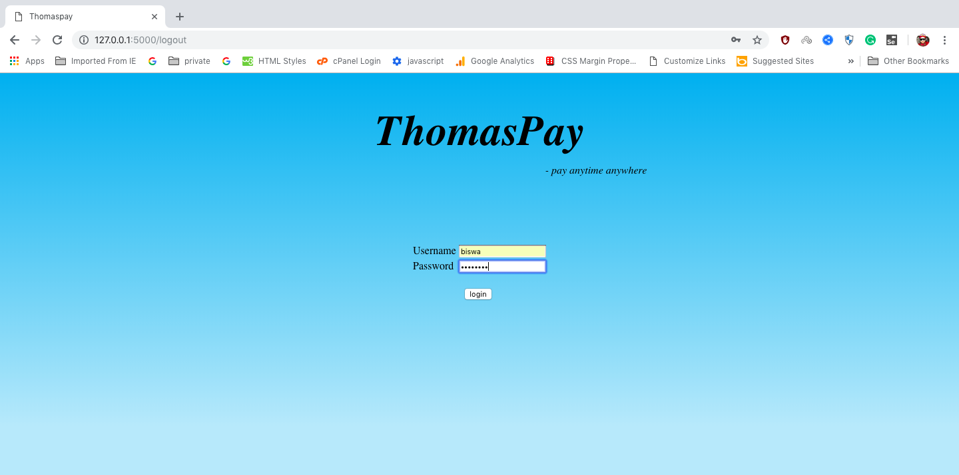

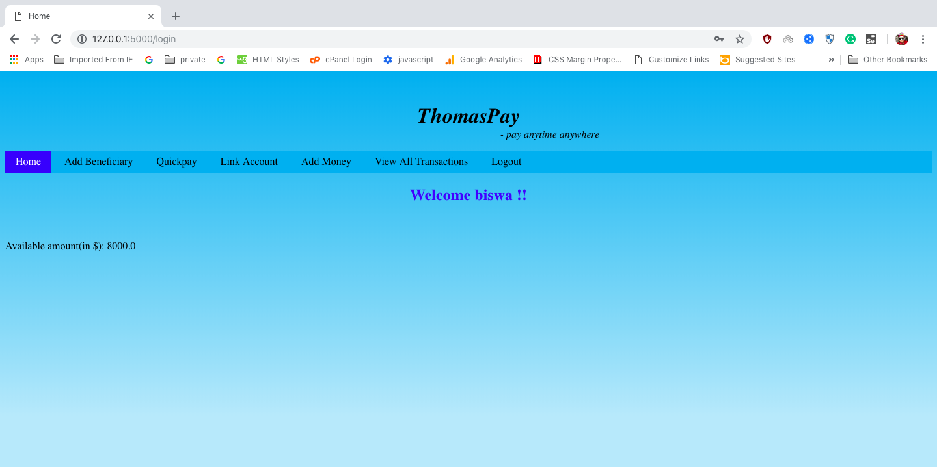

* With incorrect credentials, the User will redirected to login page with Error message “*Incorrect username or Password*”

